Practical
SUMMARY:-
In this practical, we implement graph traversal using DFS (Depth First Search) and BFS (Breadth First Search) in C. DFS explores deeply before backtracking, whereas BFS visits vertices level by level. The program takes graph edges and a starting vertex as input and displays both traversal orders and execution times.

Output:
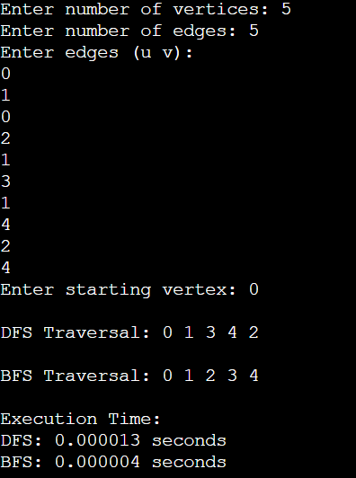

Time Complexity:
Case | DFS | BFS
Best Case | $$O\left(V^{2}\right)$$ | $$O\left(V^{2}\right)$$
Average Case | $$O\left(V^{2}\right)$$ | $$O\left(V^{2}\right)$$
Worst Case | $$O\left(V^{2}\right)$$ | $$O\left(V^{2}\right)$$
Where, $V$represents the number of vertices.

Space Complexity:
- Adjacency matrix: $O\left(V^{2}\right)$
- DFS and BFS traversal: $O\left(V\right)$auxiliary space for the visited array and traversal storage.

Conclusion:
Thus, graph searching using DFS and BFS was successfully implemented in C. The program accepts graph input from the user, displays the traversal order of both algorithms, and measures their execution time.

